Nutritional Status Process Flow
Student Profile if student profile does not exist
Enrollment
Proceed to Nutritional Status >> Nutritional Status Report
Click the button Get Students’ Data from Enrollment
Filter according to SY, Year Level and Section, Weighing Group (Baseline, 2nd, 3rd)
Edit the data, the height and weight. Make sure that for the height it is in meter unit, while kilogram for the weight.
To Calculate the BMI – click calculate BMI from the sidebar menu.
To Generate the BMI Equivalent Text Interpretation, click Calculate BMI EQV from the sidebar menu.

For Ireneo/Tyrone
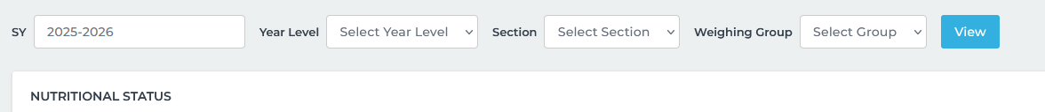
Filter the YearLevel according to the enrolled students. Do the same for Section (section is based on the selected YearLevel.

This filter is redundant
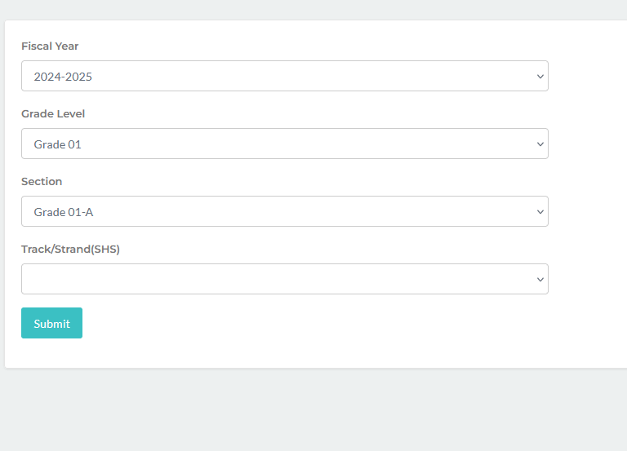
Instead get the data from Nutritional status. The button that will trigger to the report will only show once the data is view based on the criteria

